BANK LOAN PROJECT
-Ankit Samant

This document compiles all SQL queries executed during the bank loan analysis project. It covers data extraction, cleaning, segmentation, and performance evaluation across key loan metrics. The collection includes queries for borrower profiling, loan approval trends, default risk assessment, EMI calculations, and portfolio performance tracking. Together, these queries form the complete backend logic used to generate insights, dashboards, and final reports for the project.

FINDING TOTAL LOAN APPLICATION BY COUNTING THE ID
SELECT COUNT(id) AS Total_loan_application FROM bank_loan_data
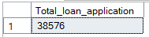

FINDING MONTH TO DATE APPLICATIONS(MTD)
SELECT COUNT(id) AS MTD_Total_Applications FROM bank_loan_data
WHERE MONTH(issue_date) = 12 AND YEAR(issue_date)=2021
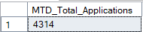
PREVIOUS MTD
SELECT COUNT(id) AS PMTD_Total_Applications FROM bank_loan_data
WHERE MONTH(issue_date) = 11 AND YEAR(issue_date)=2021
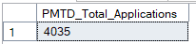

TOTAL FUNDED AMOUNT
SELECT SUM(loan_amount) AS Total_Funded_Amount FROM bank_loan_data
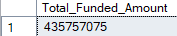

MTD FUNDED AMOUNT
SELECT SUM(loan_amount) AS Total_Funded_Amount FROM bank_loan_data
WHERE MONTH(issue_date) = 12 AND YEAR(issue_date)=2021
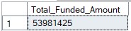
PMTD FUNDED AMOUNT
SELECT SUM(loan_amount) AS Total_Funded_Amount FROM bank_loan_data
WHERE MONTH(issue_date) = 12 AND YEAR(issue_date)=2021
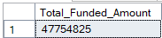
TOTAL AMOUNT REPAID
SELECT SUM(total_payment) AS Total_Amount_Repaid FROM bank_loan_data
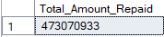

MTD TOTAL AMOUNT RECEIVED
SELECT SUM(total_payment) AS Total_Amount_Collected FROM bank_loan_data
WHERE MONTH(issue_date) = 12
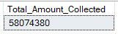
PMTD TOTAL AMOUNT RECEIVED
SELECT SUM(total_payment) AS Total_Amount_Collected FROM bank_loan_data
WHERE MONTH(issue_date) = 11
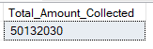
AVG INT RATE
SELECT ROUND(AVG(int_rate),4)*100 AS Average_Interest_Rate FROM bank_loan_data
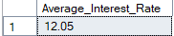

MTD AVERAGE INTEREST
SELECT ROUND(AVG(int_rate),4)*100 AS MTD_Avg_Int_Rate FROM bank_loan_data
WHERE MONTH(issue_date) = 12 AND YEAR(issue_date)=2021
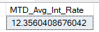
PMTD AVERAGE INTEREST
SELECT ROUND(AVG(int_rate),4)*100 AS PMTD_Avg_Int_Rate FROM bank_loan_data
WHERE MONTH(issue_date) = 11 YEAR(issue_date)=2021
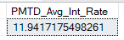
AVG DTI
SELECT ROUND(AVG(dti),4)*100 AS Average_DTI FROM bank_loan_data
MTD AVG DTI
SELECT AVG(dti)*100 AS MTD_Avg_DTI FROM bank_loan_data
WHERE MONTH(issue_date) = 12
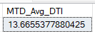
PMTD AVG DTI
SELECT AVG(dti)*100 AS PMTD_Avg_DTI FROM bank_loan_data
WHERE MONTH(issue_date) = 11
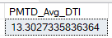
GOOD LOAN ISSUED
GOOD LOAN PERCENTAGE
SELECT
(COUNT(CASE WHEN loan_status = 'Fully Paid' OR loan_status = 'Current' THEN id END) * 100.0) /
COUNT(id) AS Good_Loan_Percentage
FROM bank_loan_data

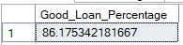

SELECT COUNT(id) AS Good_Loan_Applications FROM bank_loan_data
WHERE loan_status = 'Fully Paid' OR loan_status = 'Current'
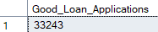
GOOD LOAN FUNDED AMOUNT
SELECT SUM(loan_amount) AS Good_Loan_Funded_amount FROM bank_loan_data
WHERE loan_status = 'Fully Paid' OR loan_status = 'Current'
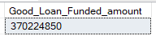
GOOD LOAN RECIEVED
SELECT SUM(total_payment) AS Good_Loan_Recieved FROM bank_loan_data
WHERE loan_status = 'Fully Paid' OR loan_status = 'Current'
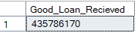
BAD LOAN ISSUED
BAD LOAN PERCENTAGE
SELECT
(COUNT(CASE WHEN loan_status = 'Charged Off' THEN id END) * 100.0) /
COUNT(id) AS Bad_Loan_Percentage
FROM bank_loan_data
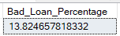
BAD LOAN APPLICATIONS
SELECT COUNT(id) AS Bad_Loan_Applications FROM bank_loan_data
WHERE loan_status = 'Charged Off'
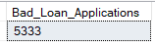
BAD LOAN FUNDED AMOUNT
SELECT SUM(loan_amount) AS Bad_Loan_Funded_amount FROM bank_loan_data
WHERE loan_status = 'Charged Off'
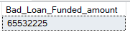
BAD LOAN AMOUNT RECEIVED
SELECT SUM(total_payment) AS Bad_Loan_amount_received FROM bank_loan_data
WHERE loan_status = 'Charged Off'
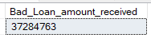

LOAN STATUS
SELECT
loan_status,
COUNT(id) AS Total_loan_applications,
SUM(total_payment) AS Total_Amount_Received,
SUM(loan_amount) AS Total_Funded_Amount,
AVG(int_rate * 100) AS Interest_Rate,
AVG(dti * 100) AS DTI
FROM
bank_loan_data
GROUP BY
loan_status
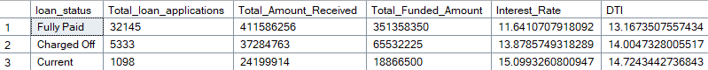

SELECT
loan_status,
SUM(total_payment) AS MTD_Total_Amount_Received,
SUM(loan_amount) AS MTD_Total_Funded_Amount
FROM bank_loan_data
WHERE MONTH(issue_date) = 12
GROUP BY loan_status
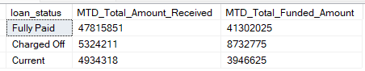

SELECT
MONTH(issue_date) AS Month_Nunber,
DATENAME(MONTH, issue_date) AS Month_name,
COUNT(id) AS Total_Loan_Applications,
SUM(loan_amount) AS Total_Funded_Amount,
SUM(total_payment) AS Total_Amount_Received
FROM bank_loan_data
GROUP BY MONTH(issue_date), DATENAME(MONTH, issue_date)
ORDER BY MONTH(issue_date)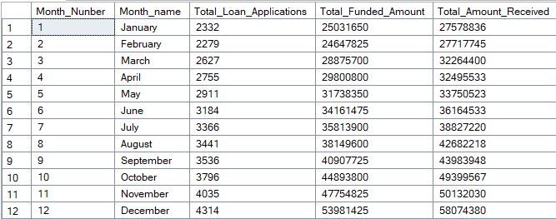
STATE
SELECT
address_state AS State,
COUNT(id) AS Total_Loan_Applications,
SUM(loan_amount) AS Total_Funded_Amount,
SUM(total_payment) AS Total_Amount_Received
FROM bank_loan_data
GROUP BY address_state
ORDER BY address_state
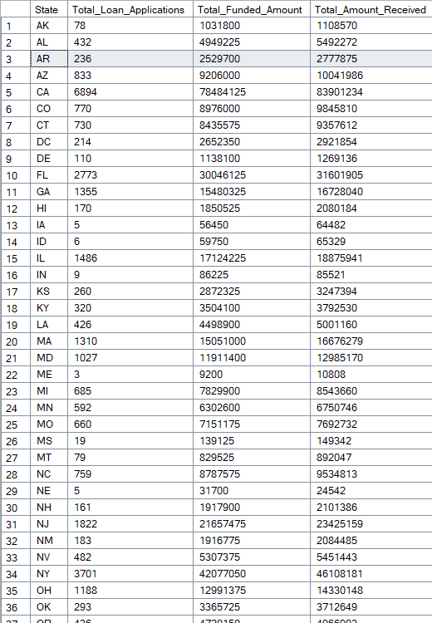

SELECT
term,
COUNT(id) AS Total_Loan_Applications,
SUM(loan_amount) AS Total_Funded_Amount,
SUM(total_payment) AS Total_Amount_Received
FROM bank_loan_data
GROUP BY term
ORDER BY term
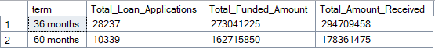
EMPLOYEE LENGTH
SELECT
emp_length AS Employee_Length,
COUNT(id) AS Total_Loan_Applications,
SUM(loan_amount) AS Total_Funded_Amount,
SUM(total_payment) AS Total_Amount_Received
FROM bank_loan_data
GROUP BY emp_length
ORDER BY emp_length
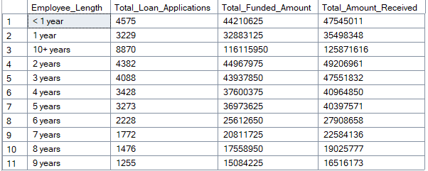

PURPOSE
SELECT
purpose AS PURPOSE,
COUNT(id) AS Total_Loan_Applications,
SUM(loan_amount) AS Total_Funded_Amount,
SUM(total_payment) AS Total_Amount_Received
FROM bank_loan_data
GROUP BY purpose
ORDER BY purpose
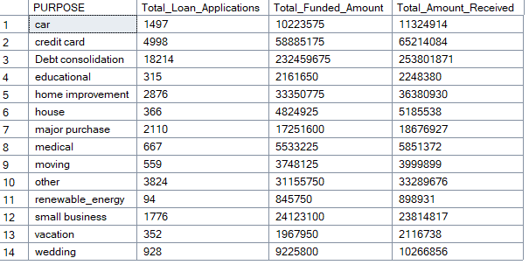

ON BASIS OF HOME OWNERSHIP
SELECT
home_ownership,
COUNT(id) AS Total_Loan_Applications,
SUM(loan_amount) AS Total_Funded_Amount,
SUM(total_payment) AS Total_Amount_Received
FROM bank_loan_data
GROUP BY home_ownership
ORDER BY COUNT(id) DESC
